Trial Western Australian Certificate of Education
Examination 2011

Question/Answer Booklet

HUMAN BIOLOGICAL SCIENCE
Stage 3

Name ___________________
Class ___________________
Teacher Name ___________________

Time allowed for this paper
Reading time before commencing work: ten minutes
Working time for paper: three hours

Materials required/recommended for this paper

To be provided by the supervisor
This Question/Answer Booklet
Multiple-choice Answer Sheet

To be provided by the candidate
Standard items: pens, pencils, eraser, correction fluid, ruler, highlighters
Special items: non-programmable calculators satisfying the conditions set by the Curriculum Council for this course

Important note to candidates
No other items may be taken into the examination room. It is your responsibility to ensure that you do not have any unauthorised notes or other items of a non-personal nature in the examination room. If you have any unauthorised material with you, hand it to the supervisor before reading any further.
Structure of this paper

Section | Number of qu available | Number of questions to be answered | Suggested working time  (minutes) | Marks available | Percentage of exam | Student Score
Section One:  Multiple-choice | 20 | 20 | 30 | 20 | 20
Section Two:  Short answer | 10 | 10 | 90 | 100 | 50
Section Three:  Extended answer | 3 | 2 | 60 | 60 | 30
 |  |  |  |  | 100

Instructions to candidates

1. The rules for the conduct of Western Australian external examinations are detailed in the Year 12 Information Handbook 2011. Sitting this examination implies that you agree to abide by these rules.

2. Answer the questions according to the following instructions.

Section One: Answer all questions on the separate Multiple-choice Answer Sheet provided. For each question shade the box to indicate your answer. Use only a blue or black pen to shade the boxes. If you make a mistake, place a cross through that square, do not erase or use correction fluid, and shade your new answer. Marks will not be deducted for incorrect answers. No marks will be given if more than one answer is completed for any question.

Sections Two and Three: Write answers in this Question/Answer Booklet.

3. You must be careful to confine your responses to the specific questions asked and to follow any instructions that are specific to a particular question.

4. Spare pages are included at the end of this booklet. They can be used for planning your responses and/or as additional space if required to continue an answer.
  - Planning: If you use the spare pages for planning, indicate this clearly at the top of the page.
  - Continuing an answer: If you need to use the space to continue an answer, indicate in the original answer space where the answer is continued, i.e. give the page number. Fill in the number of the question(s) that you are continuing to answer at the top of the page.

Section One: Multiple-choice 20% (20 Marks)

This section has 20 questions. Answer all questions on the separate Multiple-choice Answer Sheet provided. For each question shade the box to indicate your answer. Use only a blue or black pen to shade the boxes. If you make a mistake, place a cross through that square, do not erase or use correction fluid, and shade your new answer. Marks will not be deducted for incorrect answers. No marks will be given if more than one answer is completed for any question.

Suggested working time for this section is 30 minutes.

1. The following steps summarise ‘protein production’:

Step 1- DNA is copied
Step 2- Information transferred to Cytoplasm
Step 3- Information in read and protein is produced.
Step 4- Protein is released and used by the body

In which step would a mutation lead to the formation of a new allele?

(a) Step 1
(b) Step 2
(c) Step 3
(d) Step 4

2. What is a possible immune response to a pathogen?

(a) T lymphocytes produce antibodies.
(b) T helper lymphocytes are activated.
(c) B lymphocytes produce antigens
(d) B lymphocytes attack the pathogen.

3. How does immunisation limit the spread of infectious diseases?

(a) Immunisation kills pathogens.
(b) Immunisation suppresses the immune response.
(c) Immunisation prevents the entry of pathogens into the body.
(d) Immunisation reduces the multiplication of the pathogen in the body and less people will become infected.

4. In populations

(a) genetic drift will have less effect in a large population compared to a small population.
(b) bottlenecks enable a population to become better equipped for future changes in the environment.
(c) some organisms develop mutations in order to better suit them in their environment compared to other members of the population.
(d) allele frequencies remain constant if the number of individuals leaving the population equals the number of individuals entering it.

5. The Afrikaner population of South Africa has an unusually high incidence of Huntington’s disease. The Afrikaners originate from a small group of Dutch settlers. Which of the following statements offers the best explanation for the incidence of Huntington’s disease in this population?

(a) A mutation occurred in the population and has been passed on over many generations.
(b) The original Dutch settlers had a high frequency of the dominant allele.
(c) Caused by random genetic drift.
(d) The individuals affected by the disease are cared for by society and able to reproduce and pass the disease to their offspring.

6. Using gene therapy to treat a disease would involve

(a) transferring particular proteins into a person with the disease.
(b) injecting various types of blood into a person with the disease.
(c) injecting viruses that destroy certain cells of a person with the disease.
(d) transferring alleles into the cells of a person with the disease.

Question 7 and 8 refers to the following diagram of protein production

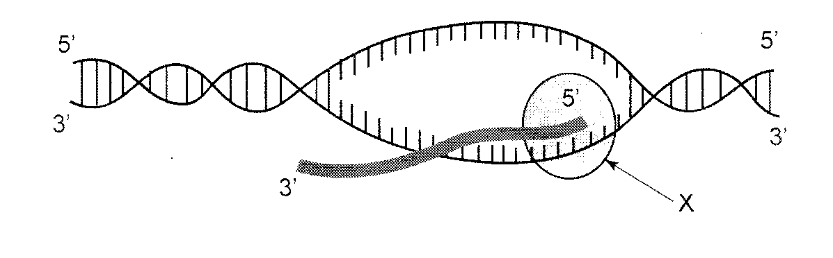

7. The diagram shows

- translation
- transcription.
- gene regulation.
- DNA replication.

8. The molecule labeled X represents

(a) ligase.
(b) a ribosome.
(c) RNA polymerase.
(d) DNA polymerase.

9. A type of bacteria causes sore throats. This bacteria was found to be susceptible to a type of antibiotic. A person with a sore throat recovered after taking this antibiotic. Several months later when the same person developed another sore throat caused by the same type of bacteria, a repeat dose of the same antibiotics was ineffective. Which of the following statements explains this situation?

(a) All the original bacteria population was resistant to the antibiotic.
(b) The antibiotic caused genes for resistance to the antibiotic to appear in the bacterial population.
(c) The person developed genes for resistance to the antibiotic.
(d) The antibiotic acted as a selecting agent for resistance in the bacterial population.

Question 10 refers to the following table for nephron function.

 | Concentration of | Substance (gL-1)
Substance | Location A | Location B | Location C
Glucose | 1.2 | 1.2 | 0
Proteins | 80 | 0 | 0
Sodium Ions | 3.2 | 3.2 | 3.3
Urea | 0.3 | 0.3 | 20
Water | 920 | 980 | 960

10. Which one of the following statements is CORRECT?

- The fluid at location B would be filtrate in the glomerular capsule.
- The fluid at location A would be urine in the glomerular capsule.
- The fluid at location B would be urine in the glomerulus.
- The fluid at location C would be filtrate in the glomerulus.

11. The contraction of the antagonistic muscles, biceps and triceps is regulated by the

(a) autonomic nervous system.
(b) medulla oblongata.
(c) somatic nervous system.
(d) hypothalamus.

12 Antivirals

(a) target and destroy most pathogens.
(b) do not destroy their target pathogen rather they inhibit their development and the detrimental effects on the body.
(c) target several viruses and reduce their respective virulence on the body.
(d) can be detrimental to the body when taken to destroy pathogens.

Question 13 refers to the following information:

A bite from a cone shellfish (a type of marine animal) injects a toxin into the body of a victim. This toxin binds to neurotransmitter receptors in the synapse. Which of the following letters in the diagram below best represents these receptors?

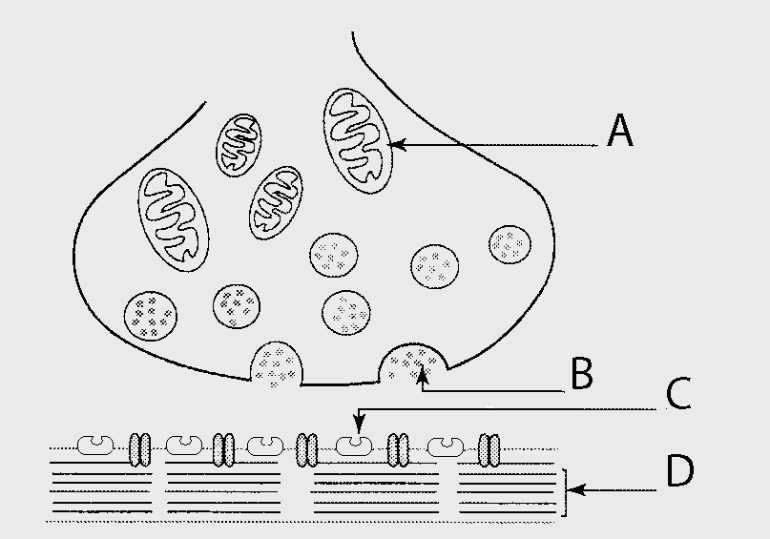

13. (a) A
(b) B
(c) C
(d) D

Question 14 refers to the following diagram of a simple spinal reflex.

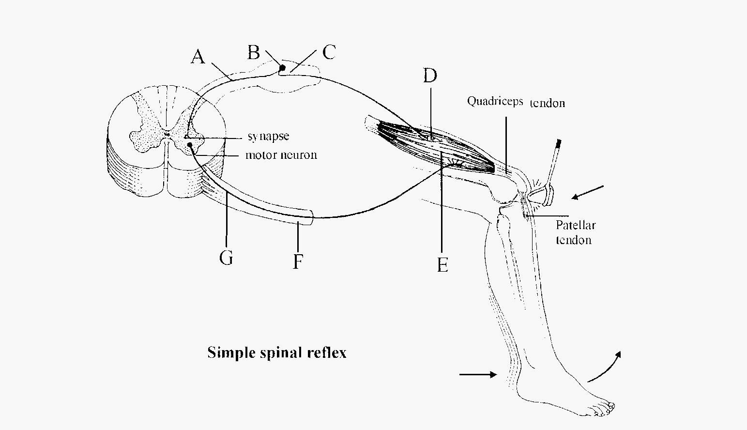

14. The efferent or motor neuron axon is located at

(a) A
(b) C
(c) F
(d) G
15. Below is a list of statements that describes ONE step in the humoral immune response:

I B cell is activated by a pathogen
II Antibodies are produced
III Pathogen reaches lymphoid tissue
IV Stimulated B cells develop in to plasma cells
V Memory cells are produced

What is the correct order of events?

(a) IV, I, II, III, V
(b) I, III, IV, II, V
(c) III, I, IV, II, V
(d) III, I, IV, V, II

Question 16 refers to the following diagram of a DNA gel.

The following DNA fingerprint was obtained from skin cells found at a crime scene. One section of the (skin) DNA molecule was separated using gel electrophoresis.

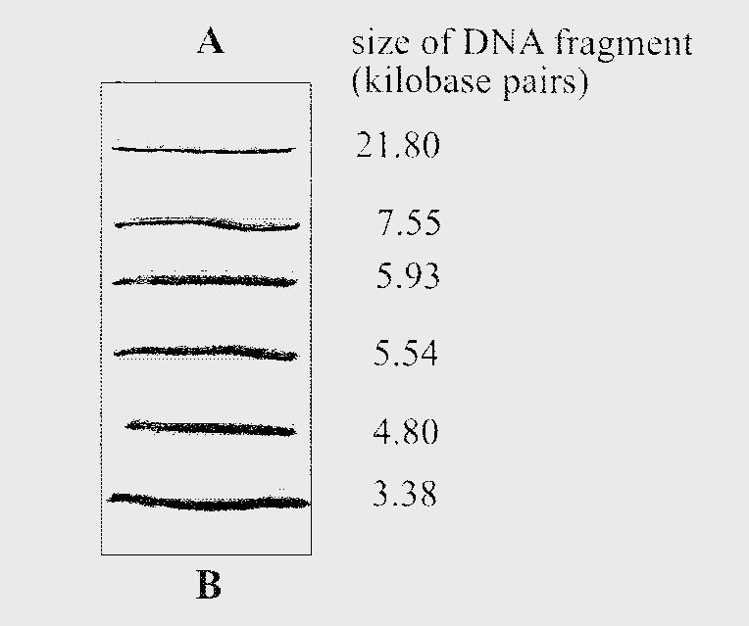

16. Which of the following statements is CORRECT?

(a) The polymerase chain reaction would have been used to multiply the section of the DNA molecule
(b) The direction of the movement of the DNA fragments is from B towards A.
(c) Three of the DNA fragments must have been inherited from the individual’s mother.
(d) The restriction enzyme must have cut the section of the DNA molecule in six places.

17. The term ‘carrying angle’ refers to the

(a) forward tilt of the body of most primates during bipedal or quadrupedal locomotion.
(b) angle created between the long axis of the femur and the vertical..
(c) orientation of the foramen magnum to the vertical axis of the skull of most primates.
(d) forward tilt of the pelvis during bipedal locomotion.

18. Which of the following ‘actions’ by the body would occur when reacting to a period of short term increase in blood pressure?

(a) Peripheral vasodilation, increased cardiac output and an increased sympathetic nervous system response.
(b) Peripheral vasodilation, decreased cardiac output and an increased sympathetic nervous system response.
(c) Peripheral vasodilation, decreased cardiac output and a decrease in the sympathetic nervous system response.
(d) Peripheral vasoconstriction, decreased in cardiac output and decrease in sympathetic response.

19. Which of the following comparisons in the table below accurately reflect the differences between nervous and endocrine control?

Response | Nervous System | Endocrine System
(a) | Involves electrical messages | Involves electrical and chemical messages
(b) | Targets most parts of the body | Targets specific targets
(c) | Short duration | Long duration
(d) | Usually affects one target area but many targets cells | Usually one specific area

20. Sally, a long distance runner, took part in a laboratory test using a treadmill. She was asked to run at 8 km/hour for thirty minutes. Sally was allowed to rest for five minutes and then repeated the exercise three times. Her performance was similar on all four occasions even though her breathing rate increased greatly. The change in her breathing occurred due to

(a) a decrease in the blood pH and this change was detected by the chemo- receptors located in the hypothalamus.
(b) an increase in the blood pH and this change was detected by chemo-receptors located in the medulla oblongata.
(c) a decrease in her cardiac output and this change was regulated by the medulla oblongata.
(d) a decrease in the blood pH and this change was detected by the chemo- receptors in the aorta and carotid arteries.

End of Section One

Section Two: Short answer 50% (100 Marks)

This section has ten questions. Answer all questions. Write your answers in the space provided.

Spare pages are included at the end of this booklet. They can be used for planning your responses and/or as additional space if required to continue an answer.
  - Planning: If you use the spare pages for planning, indicate this clearly at the top of the page.
  - Continuing an answer: If you need to use the space to continue an answer, indicate in the original answer space where the answer is continued, i.e. give the page number. Fill in the number of the question(s) that you are continuing to answer at the top of the page.

Suggested working time for this section is 90 minutes.

Question 21 (10 marks)

The following experiment was conducted. Two groups of people were tested one hour after the ingestion of 75 grams of glucose. The test monitored of their blood glucose and insulin levels. One of the groups consisted of people with diabetes and the other group acted as a control group. The following results (in mmol/L) were obtained from both groups:

 | Group | A | Group | B
Time after glucose ingestion | 0 minutes | 60 minutes | 0 minutes | 60 minutes
Plasma glucose levels | 5.3 | 13.0 | 5.3 | 7.8
Plasma Insulin Levels | 70 | 70 | 70 | 350

(a) What is the purpose of the control group? (1 mark)

______________________________________________________________________

(b) (i) Which group (A or B) contained people with diabetes? (1 mark)

______________________________________________________________________

(ii) Give two reasons for your answer in (b) (i) (2 marks)

________________________________________________________________________________________________________________________________________________________________________________________________________________________________________________________________________________________
(c) Over time, the average plasma glucose level in the control group returned to 5.3mmol/L. Explain how this change occurred. (2 marks)

__________________________________________________________________________________________________________________________________________________________________________________________________________________

(d) The experimental group consisted of people described as ‘Type 2 Diabetics’. How did they develop ‘Type 2 Diabetes’? (2 marks)

______________________________________________________________________
__________________________________________________________________________________________________________________________________________________________________________________________________________________

(e) What hormones, other than insulin, are involved in the regulation of blood glucose levels? (2 marks)

________________________________________________________________________________________________________________________________________________________________________________________________________________________________________________________________________________________

Question 22 (10 marks)

Water reabsorption occurs in the kidneys. The volume of water reabsorbed into the blood depends upon the permeability of the tubules which are controlled by other parts of the body. This reabsorption of water can also be influenced by other factors.

(a) Explain why and how larger urine volumes tend to be produced on a cold day. (2 marks)

(b) Sometimes the secretion of antidiuretic hormone into the blood is high.

(i) Where is antidiuretic hormone produced? (1 mark)

(ii) What is the effect of high blood levels of anti-diuretic hormone on the body?(2 marks)

(c) Explain why individuals suffering ‘Type 1 Diabetes’ produce high volumes of urine. (2 marks)

Use the following diagram to answer question 22 (d).

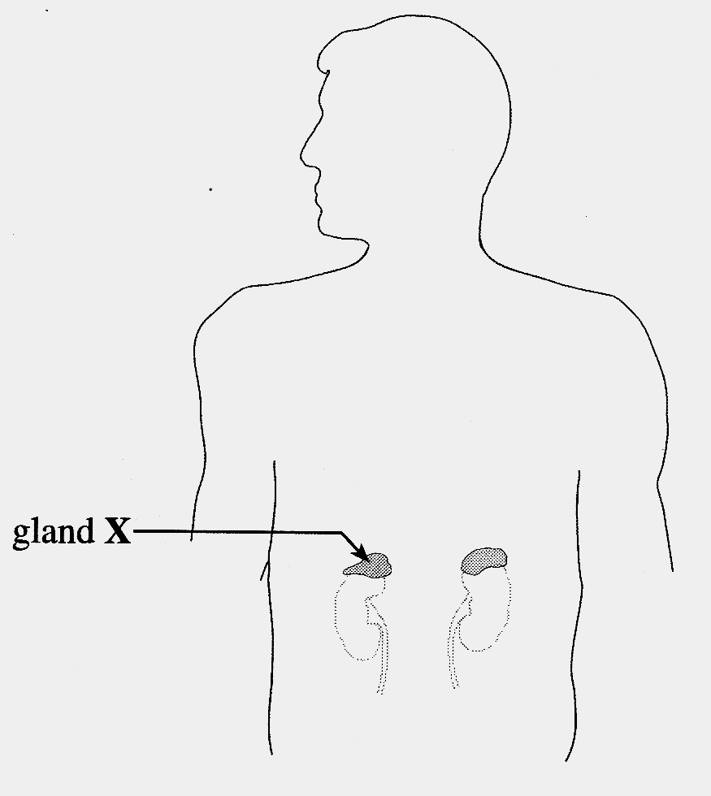

(d) (i) Identify gland X ______________________________ (1 mark)

(ii) What hormone (other than ADH) does gland X secrete to regulate the composition of urine?

_________________________________________________________ (1 mark)

(iii) What effect does this hormone have on the composition of urine? (1 mark)

Question 23 (12 marks)

Absolute dating relies on scientific techniques that allow actual fossil age to be determined. One absolute dating technique is radiocarbon dating. The following table shows the radioactive decay of carbon 14 (C¹⁴) over 35 000 years.

Time (years) | Percentage of original radioactivity
0 | 100
5000 | 54
10000 | 29
15000 | 16
20000 | 8
25000 | 5
30000 | 2
35000 | 1

(a) Graph the results from the table on the grid provided on the next page. (5 marks)

(If you wish to have a second attempt at the graph, the grid is repeated on page 42 at the end of this Question/Answer Booklet. Indicate clearly on this page if you have used the second grid and cancel the working on the grid on this page.)



(b) Define what is meant by the half life of an isotope. (2 marks)

(c) A fossil was found to contain 40% of its original radioactivity. What is the approximate age of this fossil? (1 mark)

(d) Explain why the measurement of carbon 14 (C¹⁴) in a hominin fossil may not be a useful radiometric dating technique (2 marks)

(e) Briefly explain how fossils provide scientists with compelling evidence for evolution. (2 marks)

Question 24 (8 marks)

(a) Compete the table below by writing the term translation or transcription next to the statement in reference to protein synthesis.
(2 marks)

Statement | Stage of Protein Synthesis
Ribosomes are involved

tRNA is involved

mRNA is made

DNA acts as a template

The table shows some amino acids and their corresponding tRNA anti-codon. The tRNA anti-codon for a stop signal is also shown. Below the table, a section of DNA is also shown. Use this information to answer Questions (b) to (f).

Amino acid/stop signal | tRNA anti- codon
Alanine | CGG CGA CGU CGC
Arginine | GCA GCG GCU GCC
Cysteine | ACA ACG
Glutamine | CUU CUC
Glycine | CCU CCG CCA CCC
Leucine | GAA GAG GAU GAC
Proline | GGU GGG GGA
Serine | AGG AGA AGU AGC
Stop signal | AUU AUC ACU
Threonine | UGC UGA UGU UGG

DNA Strand

A C A C T T A C A G C C G G T G G G

Codon 84 Codon 85 Codon 86 Codon 87 Codon 88 Codon 89
______________________________________________________________________

(b) What is the sequence of bases on the messenger RNA for codon 85? (1 mark)

(c) List the sequence of amino acids found in the polypeptide chain that is coded for by the DNA strand above.
(2 marks)

(d) List the sequence of bases on a molecule of messenger RNA (mRNA) synthesised from
the DNA strand above.
(1 mark)

(e) Codon 89 coded for the last amino acid in the polypeptide chain. What is the next codon? (1 mark)

(f) If a point mutation occurred in codon 86 and C was replaced by G, what amino acid would be inserted into the polypeptide chain at this point?
(1 mark)

Question 25 (14 marks)

The diagram below illustrates three steps involved in the Polymerase Chain Reaction (PCR).

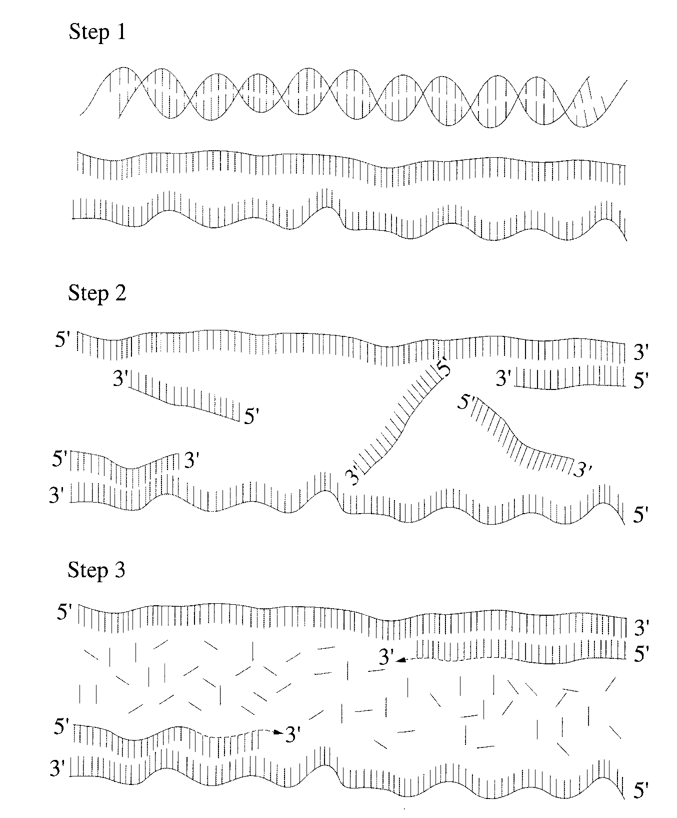

(a) Describe what is happening in each of the steps shown in the diagram above. (3 marks)

(b) Describe one use for the PCR process. (2 marks)

(c) Recombinant DNA technology involves the introduction into cells of DNA that is foreign to
the organism or that has been modified. It could be used for the benefit of individuals
suffering from a disease caused by a faulty gene or genes. Explain what is meant by the
following terms in relation to recombinant DNA technology:

(i) DNA ligase: (2 marks)

(ii) Ligation: (2 marks)

(iii) Plasmids: (2 marks)

(d) Describe the use of DNA recombinant technology in the manufacture of ONE hormone.

(3 marks)

Question 26 (9 marks)

The diagram below shows a nerve impulse travelling along an axon.

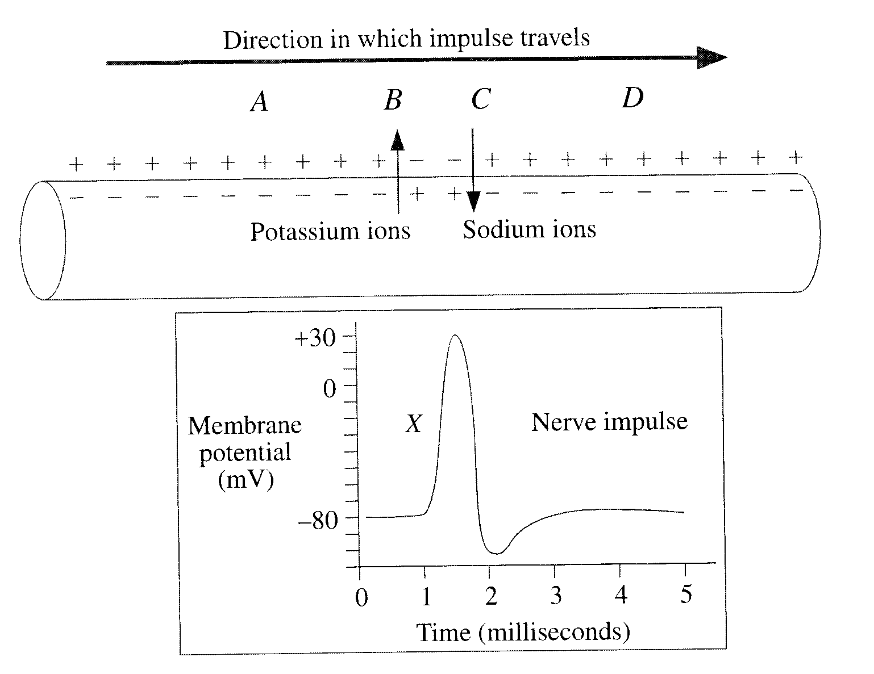

(a) (i) At which point (A, B, C or D on the axon) does the depolarisation of the nerve impulse (marked X in the graph) commence? (1 mark)

(ii) Explain your choice of answer in question (a) (i). (2 marks)

(b) What process maintains the correct amounts of potassium and sodium ions after the membrane potential returns to its resting level?
(1 mark)

(c) How does a nerve fibre transmit information that enables muscle fibres to vary the strength of contraction? (2 marks)

(d) Neurotransmitters allow a nerve impulse to move from one neuron to another. What happens to a neurotransmitter after it is released into the synaptic cleft?
(1 mark)

(e) A Red-Back Spider’s bite causes the wastage or breakdown of acetylcholine. What is acetylcholine and what is the effect on the nervous system to a person if bitten? (2 marks)

Question 27 (12 marks)

Comparison between the brain size and shape of several primates are shown below.

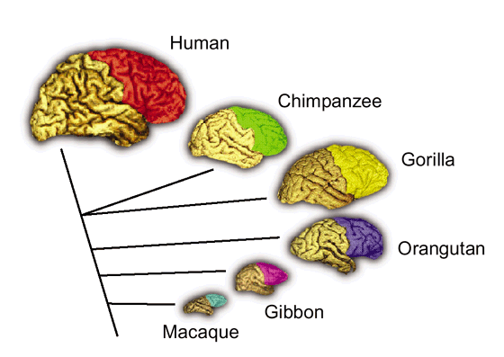

(a) Two brain regions that have changed significantly from the lesser to the higher primate
are the centres for olfaction and vision. Explain how these changes provide information about the trend in the olfactory and optical shift in primate. (2 marks)

(b) Teeth shape and dental arrangements show another trend in primate evolution.

(i) What dental arcade or arch shape do most primates share? (1 mark)

(ii) Most primates have 36 teeth whilst some have 32 teeth. Give the two dental
formulas and name and describe the different primate teeth types.
(3 marks)

When comparing a Modern human skull to other hominin skulls (see below), evolutionary changes are evident.

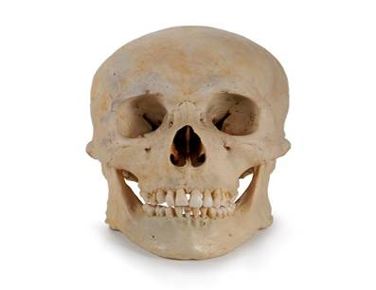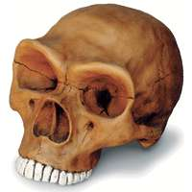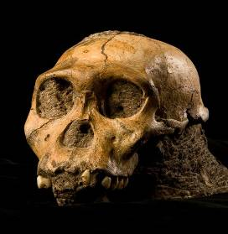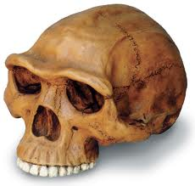
Modern Human Skull

(c) Identify and describe THREE evolutionary changes evident in the skulls shown above
and suggest ONE reason for each change.
(6 marks)

Evolutionary Change | Reason for Change

Question 28 (5 marks)

A genetic test for prospective parents could almost eliminate the chances of them having children with inherited diseases such as cystic fibrosis. This technique can that identify whether people carry genetic mutations that could cause up to 600 life-threatening disorders. Once identified, an individual could be treated or cured by gene therapy.

(a) Gene therapy has been made possible by the Human Genome Project. What was the Human Genome Project? (1 mark)

(b) Describe ONE medical advancement that has occurred due to the Human Genome Project? (2 marks)

(c) Another area or field of gene study is Epigenetics. It has been described:

‘as the pursuit of science to clarify the mechanism by which environmental factors modify the activity of genes or gene products to the detriment of an individual.’

What does this mean? Give an example of an environmental factor currently being studied. (2 marks)

Question 29 (10 marks)

The body’s defences against disease can be non-specific or specific. Pathogens that penetrate the non-specific barriers are confronted by the specific defences and are usually destroyed by these defences.

(a) What does the term ‘specific resistance’ to pathogens mean? (1 mark)

T-cells play a crucial role in the body defences against disease and health complications experienced by a person.

(b) What foreign micro-organisms are recognised by T-cells? (2 marks)

(c) Describe the process that occurs to T-cells when activated or sensitised by a foreign antigens. (4 marks)

Serious side effects were suffered by an unusual number of children to a type of ‘flu’ vaccine in 2010. The probable cause of this problem was due to an unstable vaccine. This type of adverse reaction is rarely seen in widespread vaccination programs that prevent the spreading of serious infections.

(d) What is a vaccine? (1 mark)

(e) Comment on the type of immunity provided by a vaccination and the duration of the immunity.
(2 marks)

Question 30 (10 marks)
Question 30 (9 mark
(a) Hormones can be classified into two groups; steroid (lipid soluble) or protein (water soluble) based on their mode of action. Describe TWO differences between them in the table below. (4 marks)

Type of Hormone | Difference One | Difference Two
Steroid
Protein

In women, oestrogen, a type of steroid hormone, is given to treat osteoporosis. This disease is described as individuals with brittle bones and experiencing an increase rate of fractures.

(b) Describe at the cellular level in bones how brittle bones can form. (2 marks)

Researchers have recently found that ‘bone strengthening’ drugs taken to decrease the risk fractures can possibly extend a woman’s life by five years. One other benefit of this treatment is an increased synovial joint mobility.

(c) (i) Give an example of a synovial joint and its classification? (2 marks)

(ii) Describe other methods for treating osteoporosis. (2 marks)

End of Section Two
Section Three: Extended answer 30% (60 Marks)

This section contains three (3) questions. You must answer two (2) questions. Write your answers in the space provided.

Spare pages are included at the end of this booklet. They can be used for planning your responses and/or as additional space if required to continue an answer.
  - Planning: If you use the spare pages for planning, indicate this clearly at the top of the page.
  - Continuing an answer: If you need to use the space to continue an answer, indicate in the original answer space where the answer is continued, i.e. give the page number. Fill in the number of the question(s) that you are continuing to answer at the top of the page.

Responses could include clearly labelled diagrams with explanatory notes; lists of points with linking sentences; clearly labelled tables and graphs; and annotated flow diagrams with introductory notes.

Suggested working time: 60 minutes.

Question 31 (30 marks)

The body is composed of four main tissue types that collectively support the body and allow movement to occur; however, their individual role in the body is quite specific.

(a) Discuss the macroscopic structure, locations and normal functions of bone, cartilage and muscle in the body.

(12 marks)

(b) The contraction of muscles is under voluntary control. Describe the microscopic structure of voluntary muscles and the role of myosin and actin in muscular contraction.

(8 marks)

(c) Body movement can become very restricted with time or ageing. Diseases of the skeleton like osteoarthritis are becoming prevalent. Discuss the use of medical technologies (mechanical and biological) in addressing the issues of ageing in the musculoskeletal systems.

(10 marks)
Question 32 (30 marks)

German scientists are currently creating the Neanderthal genome and have presently compiled over 60% of the estimated three billion biochemical units that makeup our extinct relative. This research is based on a fossil find 40 000 year old Neanderthal bones found in a Croatian cave. Similarly our genome also contains three million base pairs. So far, the Neanderthals base pairs are 99.7% identical to the human base pairs with slight variations in the intellectual, wound healing and metabolic gene areas.

(a) What are ‘base pairs’ and is the general role of these ‘base pairs’ in the body? Explain what the term genome means.

(4 marks)

(b) Describe how gene expression leads to the synthesis of new protein(s) thus causing variations in different species of hominins. In your response, refer to the role of specific cell structures and/or orgenelles.

(10 marks)

Neanderthals are the most recent extinct relative of modern humans. Whilst numerous fossil and artefacts finds are limited; however, they clearly show a change in trends in Neanderthal biological and cultural evolution.

(c) Describe the skeletal adaptations for bipedalism that you would observe in a preserved Neanderthal skeleton.

(10 marks)

(d) What is culture? Give some hominin examples of culture excluding Homo sapiens. What cultural advances (eg tools) are attributed to Neanderthals?

(6 marks)

Question 33 (30 marks)

In 1775, two men walked into an ‘oven’ at 127ºC. After 20 minutes, both men walked out unharmed. In contrast, a piece of meat that they carried in was partially cooked.

(a) Using the regulation of body temperature, describe the components of the stimulus-response feedback model using physiological mechanisms that would have ‘protected’ the men at a temperature of 127ºC.
(12 marks)

(b) During body temperature changes, the thyroid gland plays a significant role in temperature regulation. Discuss how the thyroid gland will help maintain a lower body temperature when we are exposed to higher external temperatures.

(8 marks)

(c) Unfortunately, some individuals will experience an abnormal thyroid function and suffer from either hypo- or hyperthyroidism. Explain what each one means, what effects are experienced by a sufferer and any possible treatments available.
(10 marks)

End of Questions

Additional working space

Use the grid to answer question 23(a) if you have cancelled your first attempt.

